An Adaptive Machine Learning Framework for Explainable Phishing Website Detection

HARSHINI S R
Computer Science and Engineering
K L H Deemed to be University
Bowrampet, Hyderabad
2420030113@klh.edu.in
PRIYANKA PILYANI
Computer Science and Engineering
K L H Deemed to be University
Bowrampet, Hyderabad
2420030132@klh.edu.in
MANICHARAN CHAVA
Computer Science and Engineering
K L H Deemed to be University
Bowrampet, Hyderabad
2420030545@klh.edu.in

Abstract—Phishing websites represent a significant cybersecurity risk by impersonating legitimate sites to deceive users into revealing their credentials, financial information, and personal data. The conventional blacklist and rule-based approaches are mostly inefficient in detecting new phishing sites. Thus, this paper proposes an adaptive multi-feature approach for classifying phishing websites in real-time. This approach employs several features related to a website including URL structure, domain property, HTTPS status, redirection, and content analysis. The study undertook data preprocessing and feature selection before classifying the websites as legitimate, phishing, and suspicious using various machine learning algorithms. The performance of the best-fit algorithm was evaluated using classification metrics. The framework was designed to interpret the features of a submitted website URL and provide an intelligent guess based on the identified features. The framework will continuously retrain its database to enhance its performance in identifying phishing websites. The proposed methodology aims to contribute to a better and more transparent approach to improving the security of the web ecosystem by reducing reliance on centralized phishing site blacklists.
Keywords—Phishing detection, machine learning, cybersecurity, real time detection, feature selection, website classification, risk assessment, web security.

Introduction
Phishing is a prominent cybercrime where the adversary designs a deceptive website that imitates the characteristic attributes of legitimate websites to extract sensitive personal information from users. The proliferation of online banking, electronic transactions, cloud services, and web-based applications has increased the risk of phishing attacks as users interact with various digital platforms to carry out day-to-day activities. The presence of phishing websites causes significant security risks, including the exposure of the system to malware infections and unauthorized access to user data. The phishing attack detection problem holds great significance in the field of cybersecurity.
The traditional phishing detection techniques rely on the presence of blacklists, appropriate whitelists, URL reputation scores, and rule-based systems. However, such approaches exhibit poor results due to the dynamic nature of phishing websites and the inability to capture the characteristics of the sites accurately. The phishing sites can deliver misleading information, employ obfuscation methods, use short-lived URLs, and dynamically redirect to confuse the detectors. Furthermore, individual features may lack sufficient information for the detection approach to classify the website accurately. The machine learning methods address the limitations of rule based and traditional phishing detection techniques by exploring different website features to derive a consistent understanding of the website’s characteristics. Multiple studies have employed classification algorithms such as Decision Tree, Random Forest, Logistic Regression, Support Vector Machine, XGBoost, and neural networks to develop a robust approach for detecting phishing websites. However, the existing studies vary significantly in terms of the features used for classification, datasets, performance evaluation techniques, and deployment aspects. The majority of the works focus only on the URL features or domain level attributes. Moreover, some approaches such as random forest, logistic regression, and XGBoost fail to offer a real time solution as they are evaluated on a static test set.
This paper proposes an Adaptive Multi Feature Machine learning Framework for Real Time Phishing Website Detection. The framework aims to combine the multiple classification features such as URL attributes, domain characteristics, HTTPS features, redirect attributes, and content attributes to detect the phishing websites. The framework conducts an exhaustive analysis of machine learning algorithms and their performance, employing the classification metrics of accuracy, precision, recall, F1 score, and false positive rate for evaluation. The trained model can take a URL as input and classify it as legitimate, suspicious, or phishing.
The framework also implements an explainable phishing risk assessment system that explains the attributes that influence the prediction result. An adaptive system update mechanism enables the system to update the model using the newly uploaded phishing website data to enhance its performance. The framework offers significant advantages over the existing approaches by addressing the research gaps of comprehensive feature selection, large scale data evaluation, system retraining, and performance interpretability.
The subsequent sections of this paper are organized as follows: Section II presents the literature review of the recent phishing detection approaches. Section III highlights the research gap based on the literature review. Section IV explains the methodology of the framework including the data collection, preprocessing, feature selection, and classification. Section V illustrates the system architecture and detection procedure of the framework. Section VI describes the dataset and exploratory data analysis and Section VII discusses the expected results and applications, and Section VIII presents the conclusion and future scope of the framework.

Literature Survey

Machine Learning Approaches for Phishing Detection
Phishing website detection has seen a rise in machine learning-based methodologies which analyse website features and classify them into benign or malicious categories. The first approaches employed lexical and structural properties of URLs. Kulkarni and Brown [1] experimented with Decision Tree, Naive Bayes, Support Vector Machine, and Neural Network classifiers using URL-based features. The article demonstrated the effectiveness of machine learning in phishing website detection but was limited by a static dataset and the lack of consideration of webpage content and real-time analysis. More recent work emphasizes that performance must also be tested across changing URL distributions rather than only within a single static dataset [9], [10].
The following research utilized features extracted from URLs and webpages to classify sites with the implementation of machine learning. Authors used Random Forest and Decision Tree classifiers and found that the former performed significantly better at phishing website detection [2]. The use of a small set of classifiers and the absence of an interface for analysing URLs in real-time limited the article. Feature-level interpretation can make these predictions more actionable by showing which URL or webpage characteristics contributed to the decision [11], [12].
Recent articles explore the use of hybrid and complex machine learning methods in phishing website detection. The first study published in 2024 proposed a novel hybrid approach based on URL and domain features without the use of third-party reputation systems [3]. Another study published the same year used an array of machine learning techniques for phishing detection in real-time, with particular emphasis on the effectiveness of the Logistic Regression algorithm [4]. Researchers continued to analyse the potential of Random Forest, Support Vector Machine, XGBoost, and Multilayer Perceptron in 2025 with an open-source Flask-based application and an implementation of a combination of classical, ensemble, and deep learning methods [5]. A comparative study of classical, ensemble, and deep-learning models further reported that a stacked ensemble reached about 99% accuracy, at a higher computational cost [6]. Recent studies further investigate hybrid deep-learning pipelines and pretrained transformer representations, which can capture patterns that are difficult to represent with manually engineered features alone [13]–[16].

Recent Directions: Domain Adaptation and Robust Generalization
A central challenge for phishing detection is that URL patterns and hosting infrastructure change over time. Rashid et al. examine phishing-URL generalization through unsupervised domain adaptation, highlighting the importance of evaluating whether a model transfers to a different data distribution rather than relying only on a random train-test split [9]. Studies of malicious-URL detection likewise provide a broader setting for comparing feature-driven classifiers and examining how the choice of data and features affects performance [10]. For the proposed framework, this motivates testing on a held-out dataset or a later time period, where feasible, and reporting the resulting performance separately from the ordinary test split.

Explainability and Feature Selection
A high classification score does not by itself explain why a URL is considered dangerous. Research on phishing URL detection with explainable AI motivates pairing predictions with interpretable feature evidence so that analysts and end users can inspect the reasons behind a warning [11]. Explainable-AI assessment work in cybersecurity also suggests that explanations should be judged for usefulness and consistency, not merely displayed as a visual add-on [22]. In parallel, explainable feature-selection frameworks and mutual-information-based approaches offer ways to identify informative attributes and reduce redundancy [17], [21]. These findings support the proposed combination of a risk score with a concise explanation of influential URL, domain, HTTPS, redirection, and webpage-content indicators.

Deep Learning, Transformers, and Multimodal Detection
Recent phishing-detection research explores integrated deep-learning classifiers and pretrained transformer models for URL representation [12], alongside machine-learning and deep-learning comparisons [13]. Other work investigates resistance to adversarial samples in multimodal phishing website detection, indicating that relying on one representation can leave a system exposed to carefully altered inputs [14]. Context-aware embeddings for fraudulent-URL detection and transformer-based phishing website models further demonstrate the growing interest in representations that capture contextual patterns beyond simple lexical counts [15], [16]. These approaches are relevant extensions for the proposed framework, although their computational cost, inference latency, and interpretability should be compared with classical baselines before adoption.

Operational Considerations and Dataset Quality
Phishing detection also involves operational questions beyond model accuracy. MLPhishChain explores a blockchain-supported framework for reducing phishing threats [19], while other recent work examines conventional machine-learning pipelines and case-based evaluation of phishing detection [18], [20]. These studies reinforce the need to consider how predictions are recorded, reviewed, and acted upon in a deployed system. Dataset quality is equally important: a large collection such as PhreshPhish can provide an additional evaluation resource, but its collection methodology, label quality, coverage, and permitted use should be reviewed before it is incorporated into experiments [24].

Limitations of Existing Approaches
Even though there have been numerous efforts in detecting phishing websites using machine learning techniques, there are still some shortcomings that need to be addressed. Firstly, many of the techniques depend solely on URL or domain features and do not incorporate other factors, such as HTTPS usage, redirection, and page content. This may hamper the capacity of the technique to learn about various phishing site characteristics. Feature selection is therefore important not only for reducing computation, but also for improving interpretability and limiting dependence on noisy or redundant attributes [17], [18].
Secondly, the use of a static dataset and off-line training of the model is a drawback of many of these techniques. Namely, there are no mechanisms in place to allow the real time submission of URLs and classification. Additionally, lack of regular retraining may impair the detection of new types of phishing sites and unknown phishing websites. Furthermore, most of the systems provide just a classification label but not an explanation about the characteristics of the site that led to classification. Distribution shift is a related concern: a detector trained on one collection of URLs may perform differently when deployed against another source or a later phishing campaign, motivating domain adaptation and regular evaluation on newer samples [9], [19].
This is the main motivation behind the creation of an approach that incorporates several categories of website features together with machine learning based classification.

Research Gap
Table I condenses the six studies reviewed in Section II. Across them, four recurring gaps can be identified. First, most systems rely on a narrow feature set, typically URL or domain attributes alone, and do not combine HTTPS status, redirection behavior, and webpage-content signals within a single model. Second, several works evaluate models offline on fixed and comparatively small datasets, and they offer no real-time interface for submitting a URL and receiving a classification. Third, none of the reviewed systems describes a mechanism for periodic retraining on newly collected phishing samples, which limits generalization to zero-day attacks. Fourth, predictions are usually returned as a bare label, without a risk score or an explanation of the contributing indicators, which reduces transparency for end users. Robustness should also be considered because attackers can deliberately modify URLs, page content, or visual cues to evade a detector; multimodal systems consequently require testing against adversarial examples and defensive strategies [14], [20].
- Comparative Summary of Reviewed Studies
Ref. | Method and reported result | Key limitation
[1] | DT, NB, SVM, NN on lexical URL features (1,353 URLs) | Small static dataset; URL-only features; no real-time use
[2] | Random Forest (87.0%) vs. Decision Tree (82.4%) | Accuracy below 90%; two classifiers only; no live interface
[3] | Hybrid URL + domain feature model, no third-party reputation data | No HTTPS, redirection or content features; no explanation
[4] | Real-time multi-model service; Logistic Regression best (96.38%) | Single best model; no zero-day adaptation or explanation
[5] | RF, SVM, XGBoost, MLP with Flask app; MLP best (99.03%) | One dataset; no retraining; basic demo app only
[6] | Classical, ensemble and deep models; stacked ensemble (about 99%) | High compute cost; poor explainability; no risk scoring
- DT: Decision Tree; NB: Naive Bayes; SVM: Support Vector Machine; NN: Neural Network; RF: Random Forest; MLP: Multilayer Perceptron.
The proposed framework addresses these gaps by (i) fusing URL, domain, HTTPS, redirection, and content features; (ii) supporting real-time URL submission with immediate classification; (iii) enabling periodic retraining as new phishing samples are collected; and (iv) generating an interpretable risk-based result that highlights the indicators behind each prediction. The design also draws on research into explainable feature selection and explainable-AI assessment, which supports presenting human-readable evidence alongside a classification rather than treating the model score as a complete explanation [11], [21], [22].

Proposed Methodology
The framework follows a staged pipeline from dataset collection to continuous model improvement, as summarized in Fig. 1.

Dataset Collection
A publicly available phishing-website dataset, the UCI PhiUSIIL Phishing URL Dataset [7], is used as the primary source. It contains legitimate and phishing instances described by URL, domain, and webpage-related attributes. The smaller UCI Phishing Websites Dataset [8] serves as a benchmark. The use of more than one benchmark is consistent with research that evaluates malicious-URL classifiers across datasets and investigates generalization beyond a single training distribution [9], [10].

Data Preprocessing
Missing or inconsistent values are handled and duplicate records are removed. Categorical attributes are encoded and numerical features are normalized, after which the data are split into training and testing subsets.

Feature Extraction and Selection
Features such as URL length, special-character counts, suspicious keywords, domain age, HTTPS availability, IP-address usage, redirects, and external links are extracted. The most informative subset is retained using correlation and statistical analysis, which reduces dimensionality and computational cost. Mutual-information-based selection and explainable feature-ranking methods are useful complementary baselines for assessing whether the selected attributes contribute predictive information without making the final model unnecessarily complex [17], [21], [23].

Model Training and Evaluation
Decision Tree, Random Forest, Logistic Regression, Support Vector Machine, and XGBoost classifiers are trained and compared. The best-performing model, or an ensemble of the top models, is selected for deployment. Performance is measured using accuracy, precision, recall, F1 score, and false positive rate, defined from the counts of true positives (TP), true negatives (TN), false positives (FP), and false negatives (FN) as In addition to aggregate metrics, evaluation should examine class-wise precision and recall, calibration of risk scores, and performance on temporally or geographically separated samples where available. Prior work on classical, deep-learning, and transformer-based URL detection provides a basis for comparing these model families [12]–[16], [18], [23].
Accuracy = (TP + TN) / (TP + TN + FP + FN) (1)
Precision = TP / (TP + FP) (2)
Recall = TP / (TP + FN) (3)
F1 = 2 × Precision × Recall / (Precision + Recall) (4)
FPR = FP / (FP + TN) (5)
The false positive rate is emphasized because wrongly flagging a legitimate site harms user trust.

Real-Time Classification and Risk Assessment
When a user submits a URL, the system validates it, extracts the same feature set used in training, and passes it through the trained model. The output is an immediate legitimate, suspicious, or phishing classification together with a risk score and the indicators that contributed to the decision. The explanation layer should report a small set of influential indicators—such as unusual URL structure, mismatched domain/title information, or suspicious redirect behaviour—and distinguish evidence observed directly from signals inferred by the classifier. This is aligned with work on explainable phishing detection and broader explainable-AI assessment in cybersecurity [11], [21], [22].

Continuous Model Improvement
Detection results are logged, and newly identified phishing samples are periodically added to the training set so that the model can be retrained to adapt to emerging phishing techniques. Retraining should be controlled rather than fully automatic: newly collected examples need validation, duplicate removal, label-quality checks, and regression testing before a model update is deployed. Large-scale, real-world phishing collections can support more realistic evaluation, while benchmark documentation helps make results reproducible [24].

G. Threat Model and Assumptions
The proposed detector is intended to identify deceptive websites from observable URL, domain, transport-security, redirection, and webpage-derived attributes. The assumed adversary may register look-alike domains, introduce misleading path or query strings, use URL-shortening services, or alter page content to resemble a trusted service. The detector does not assume that any single indicator, including HTTPS, is sufficient to establish legitimacy. HTTPS protects data in transit but can also be enabled on malicious websites; therefore, it is treated as one signal among several. The system is designed as a decision-support layer and should not replace browser security controls, reputation services, or user reporting mechanisms.

H. Reproducibility and Experimental Controls
To make the evaluation reproducible, the dataset version, label mapping, feature list, preprocessing operations, random seed, train-test split, and software versions should be recorded. Any feature selection must be performed using the training data only; selecting features before the split can leak information from the test set into model development. Duplicate URLs and near-duplicate records should be checked because repeated examples can inflate apparent performance. Where timestamps or collection sources are available, a time-based or source-separated test should complement a stratified random split. This is especially important for phishing detection, where URL patterns and campaigns change over time [9], [10], [24].

I. Evaluation Beyond Accuracy
Accuracy is useful as a summary measure but may conceal important errors, particularly when class prevalence differs between a benchmark and real-world traffic. The evaluation should therefore report precision, recall, F1-score, false-positive rate, a confusion matrix, and ROC-AUC where the dataset and model outputs support these measures. Precision indicates how often flagged sites are actually phishing, while recall indicates how many phishing examples are detected. False positives deserve particular attention because incorrectly warning users about legitimate websites can reduce trust in the system. For deployment-oriented evaluation, the team should additionally report inference time and inspect performance on a held-out dataset or later time period. Results from different studies should not be compared as if they were directly equivalent unless datasets, label definitions, and evaluation protocols are aligned [9], [10], [12]–[16], [18].

J. Responsible Deployment and Limitations
A prediction score is not a guarantee that a website is safe or malicious. The user interface should communicate uncertainty, avoid presenting model output as a definitive security verdict, and provide concise reasons for a warning. Model updates should be versioned and tested before release, and newly collected examples should undergo label validation and duplicate checks. The framework also inherits limitations from its training data: benchmark datasets may not represent the prevalence, languages, hosting patterns, or attack strategies encountered in production. Some features in a tabular dataset may have been extracted from webpage content that is unavailable at prediction time, so the implementation must verify that every feature can be computed consistently in the intended deployment setting. These limitations motivate periodic evaluation, dataset documentation, and careful monitoring rather than unreviewed automatic retraining [11], [14], [20]–[24].

K. Planned Visual and Quantitative Analysis
The exploratory analysis should present the class distribution, feature correlations, and the most informative features, followed by model-level evaluation using a confusion matrix and ROC curve. These figures serve different purposes: class distribution documents the composition of the dataset; a correlation heatmap reveals associations among numerical features; feature-importance rankings summarize the fitted model's reliance on selected attributes; and evaluation plots show the types of errors made by the classifier. All charts should be generated from the exact dataset version and model run used in the reported results. Captions should identify the dataset, target-label mapping, and whether values are descriptive statistics or held-out test results. No accuracy or superiority claim should be added to the paper until it is supported by an executed experiment.

System Architecture
The process begins when a user submits a website URL through a web application, a browser-integrated component, or a monitoring-service interface. The URL is validated, and its features are extracted, preprocessed, and passed to the trained model, which performs real-time classification. Based on the prediction, the system generates a risk score and displays either a security warning with the contributing indicators or a safe-status notification. Detection results are stored to support periodic updating and retraining, which allows the framework to adapt to emerging phishing techniques.
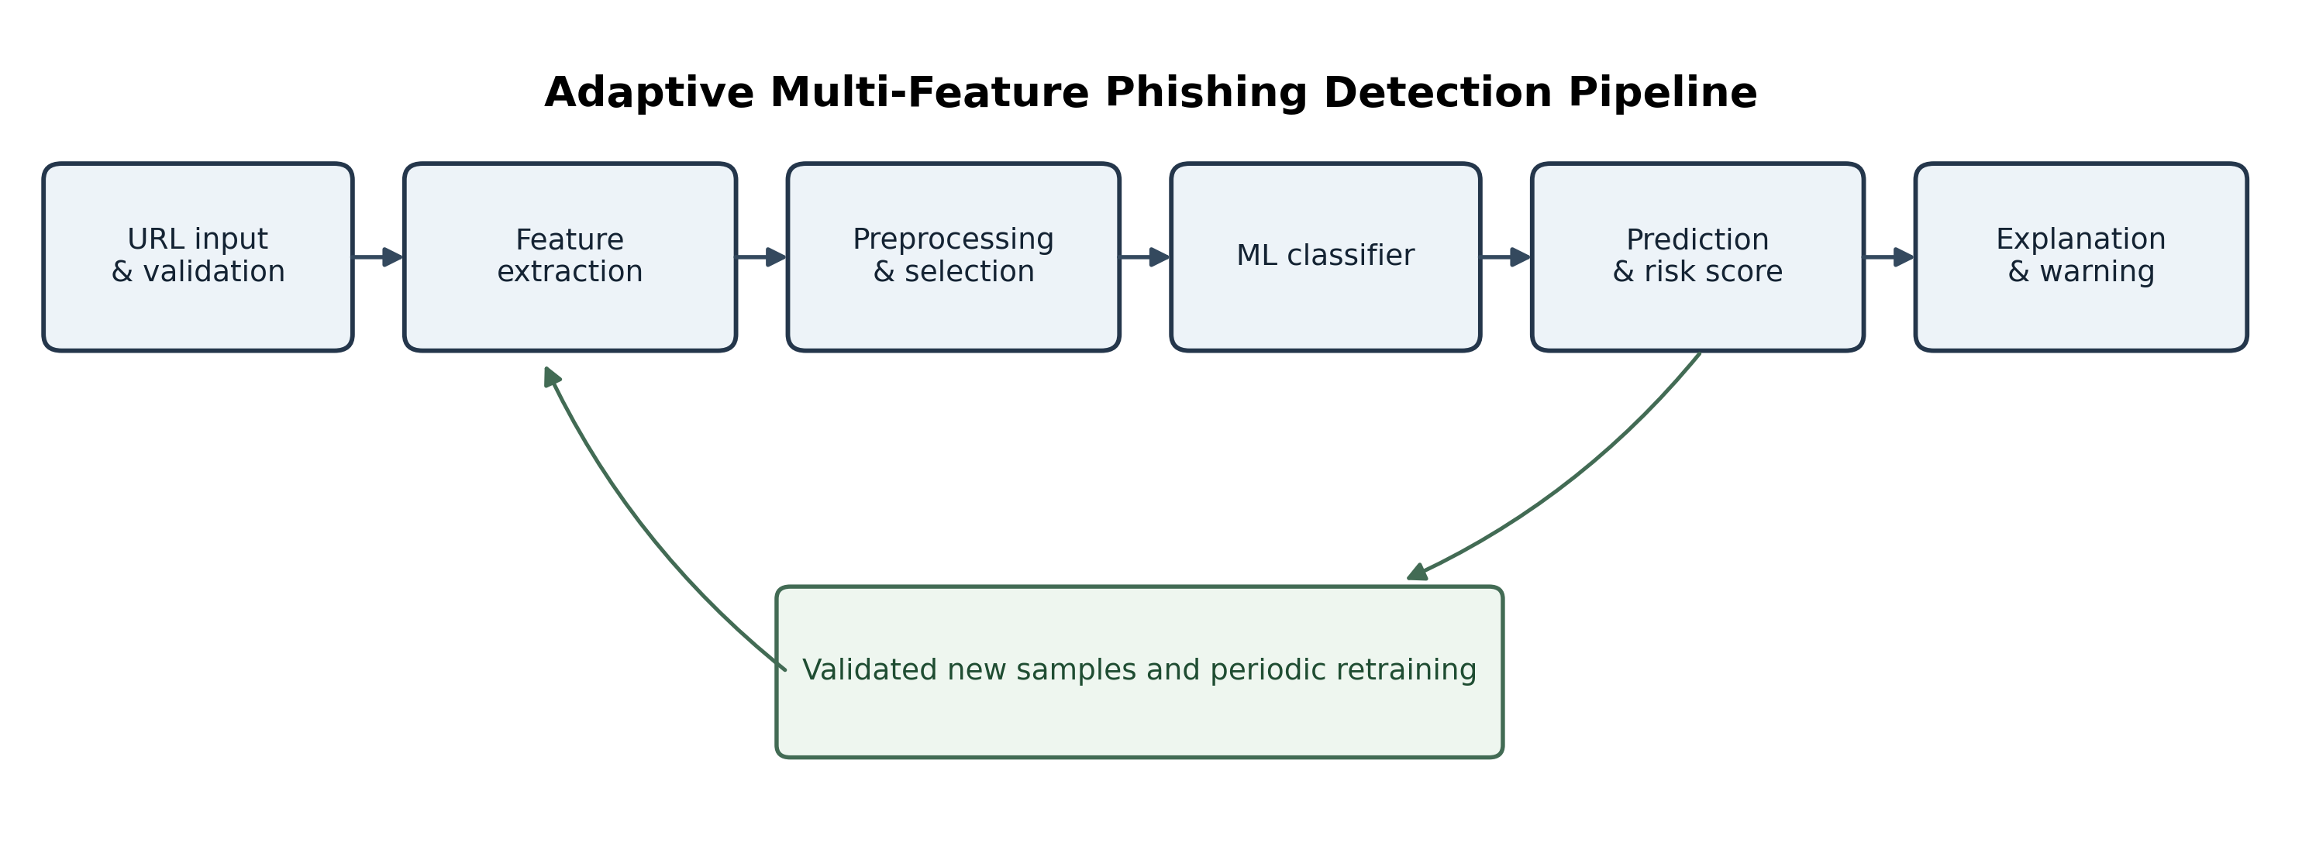
- End-to-end workflow of the adaptive multi-feature phishing detection framework.

Dataset and Exploratory Data Analysis
The framework can be trained using the UCI PhiUSIIL Phishing URL Dataset (235,795 URLs, 54 features) [7], with the UCI Phishing Websites Dataset (11,055 instances, 30 features) [8] as a smaller benchmark. The large-scale PhreshPhish dataset, with more than 666,000 HTML and URL samples, can be used for further evaluation. Exploratory data analysis (EDA) is performed to understand which characteristics most strongly separate legitimate from phishing websites. The PhreshPhish benchmark is a potential additional evaluation source because it was developed to provide a large-scale collection of real-world phishing websites; its data and licensing conditions should be checked before use [24].
Figures 1–3 summarize the proposed detection pipeline and the feature-level exploratory analysis. Fig. 2 displays pairwise correlations among selected numerical attributes, while Fig. 3 ranks features by the fitted Random Forest model's impurity-based importance. These measures are not interchangeable: correlation describes pairwise association, whereas model importance reflects the contribution used by this particular fitted estimator. Fig. 4 presents the class distribution, and Figs. 5 and 6 report held-out baseline evaluation using a confusion matrix and ROC curve. The plotted results should be interpreted with the dataset's label mapping and feature provenance in mind.
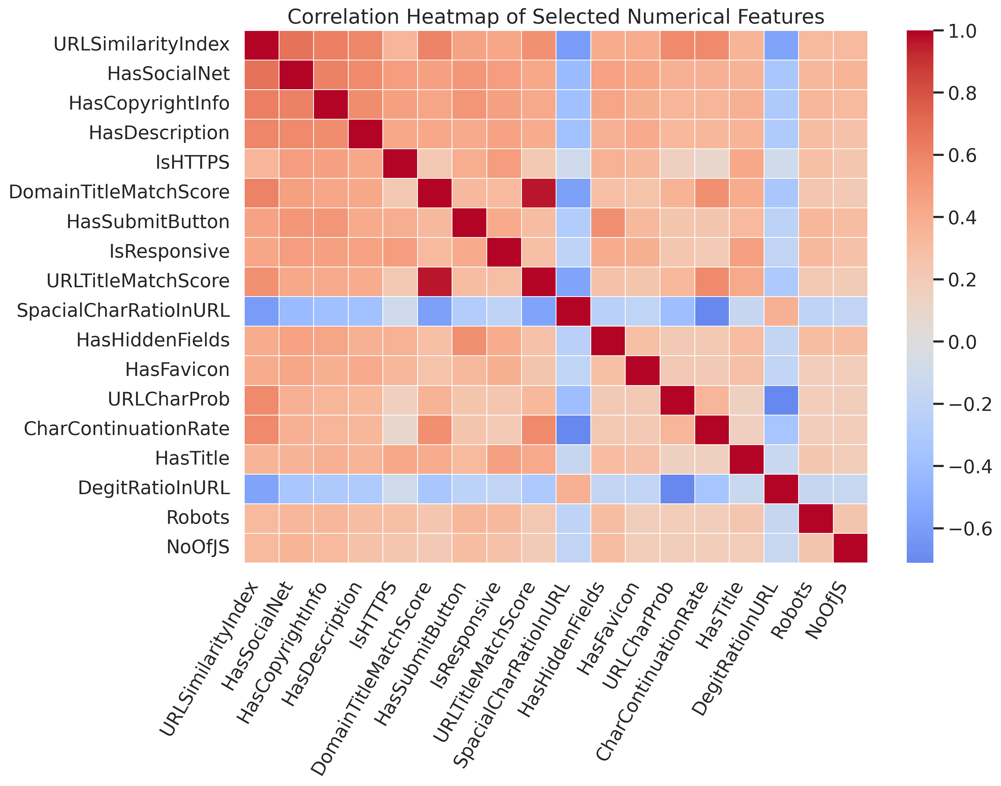
- Correlation heatmap of selected numerical features in the UCI PhiUSIIL dataset.
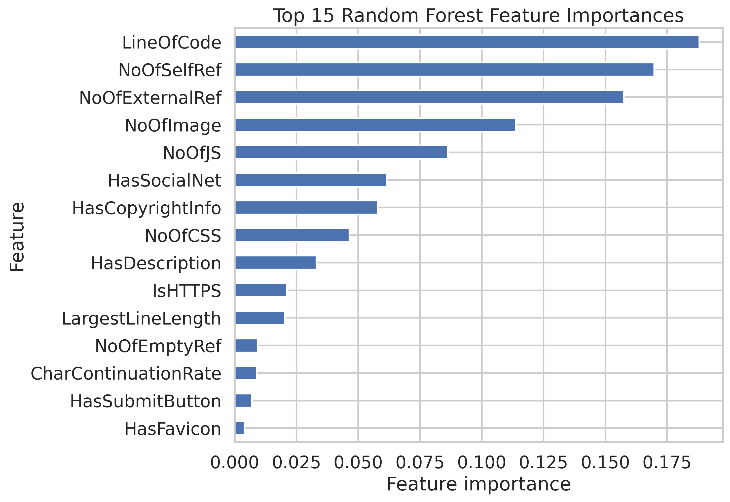
- Fifteen most important features in the fitted Random Forest baseline.
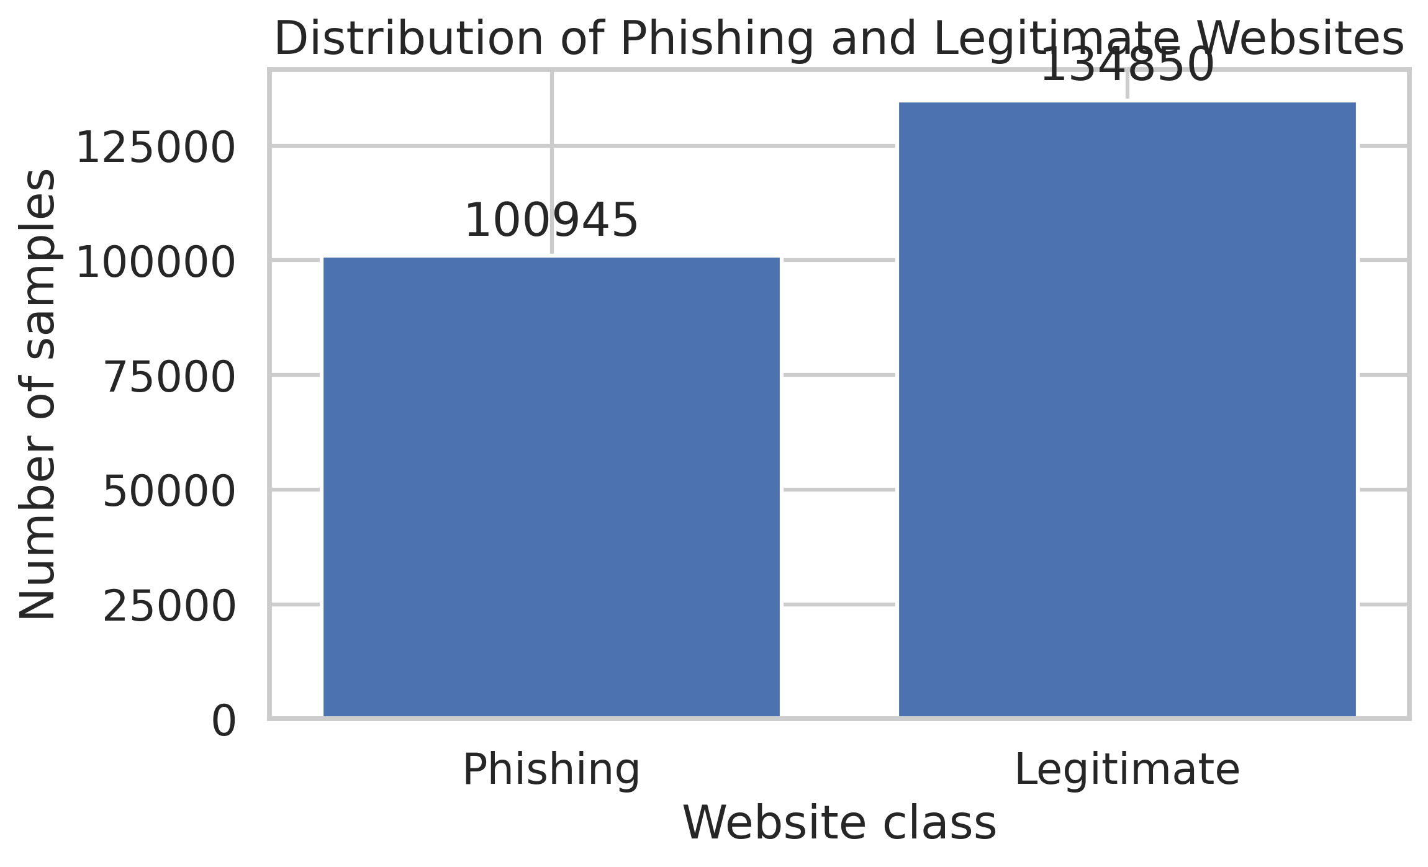
- Class distribution in the UCI PhiUSIIL dataset.
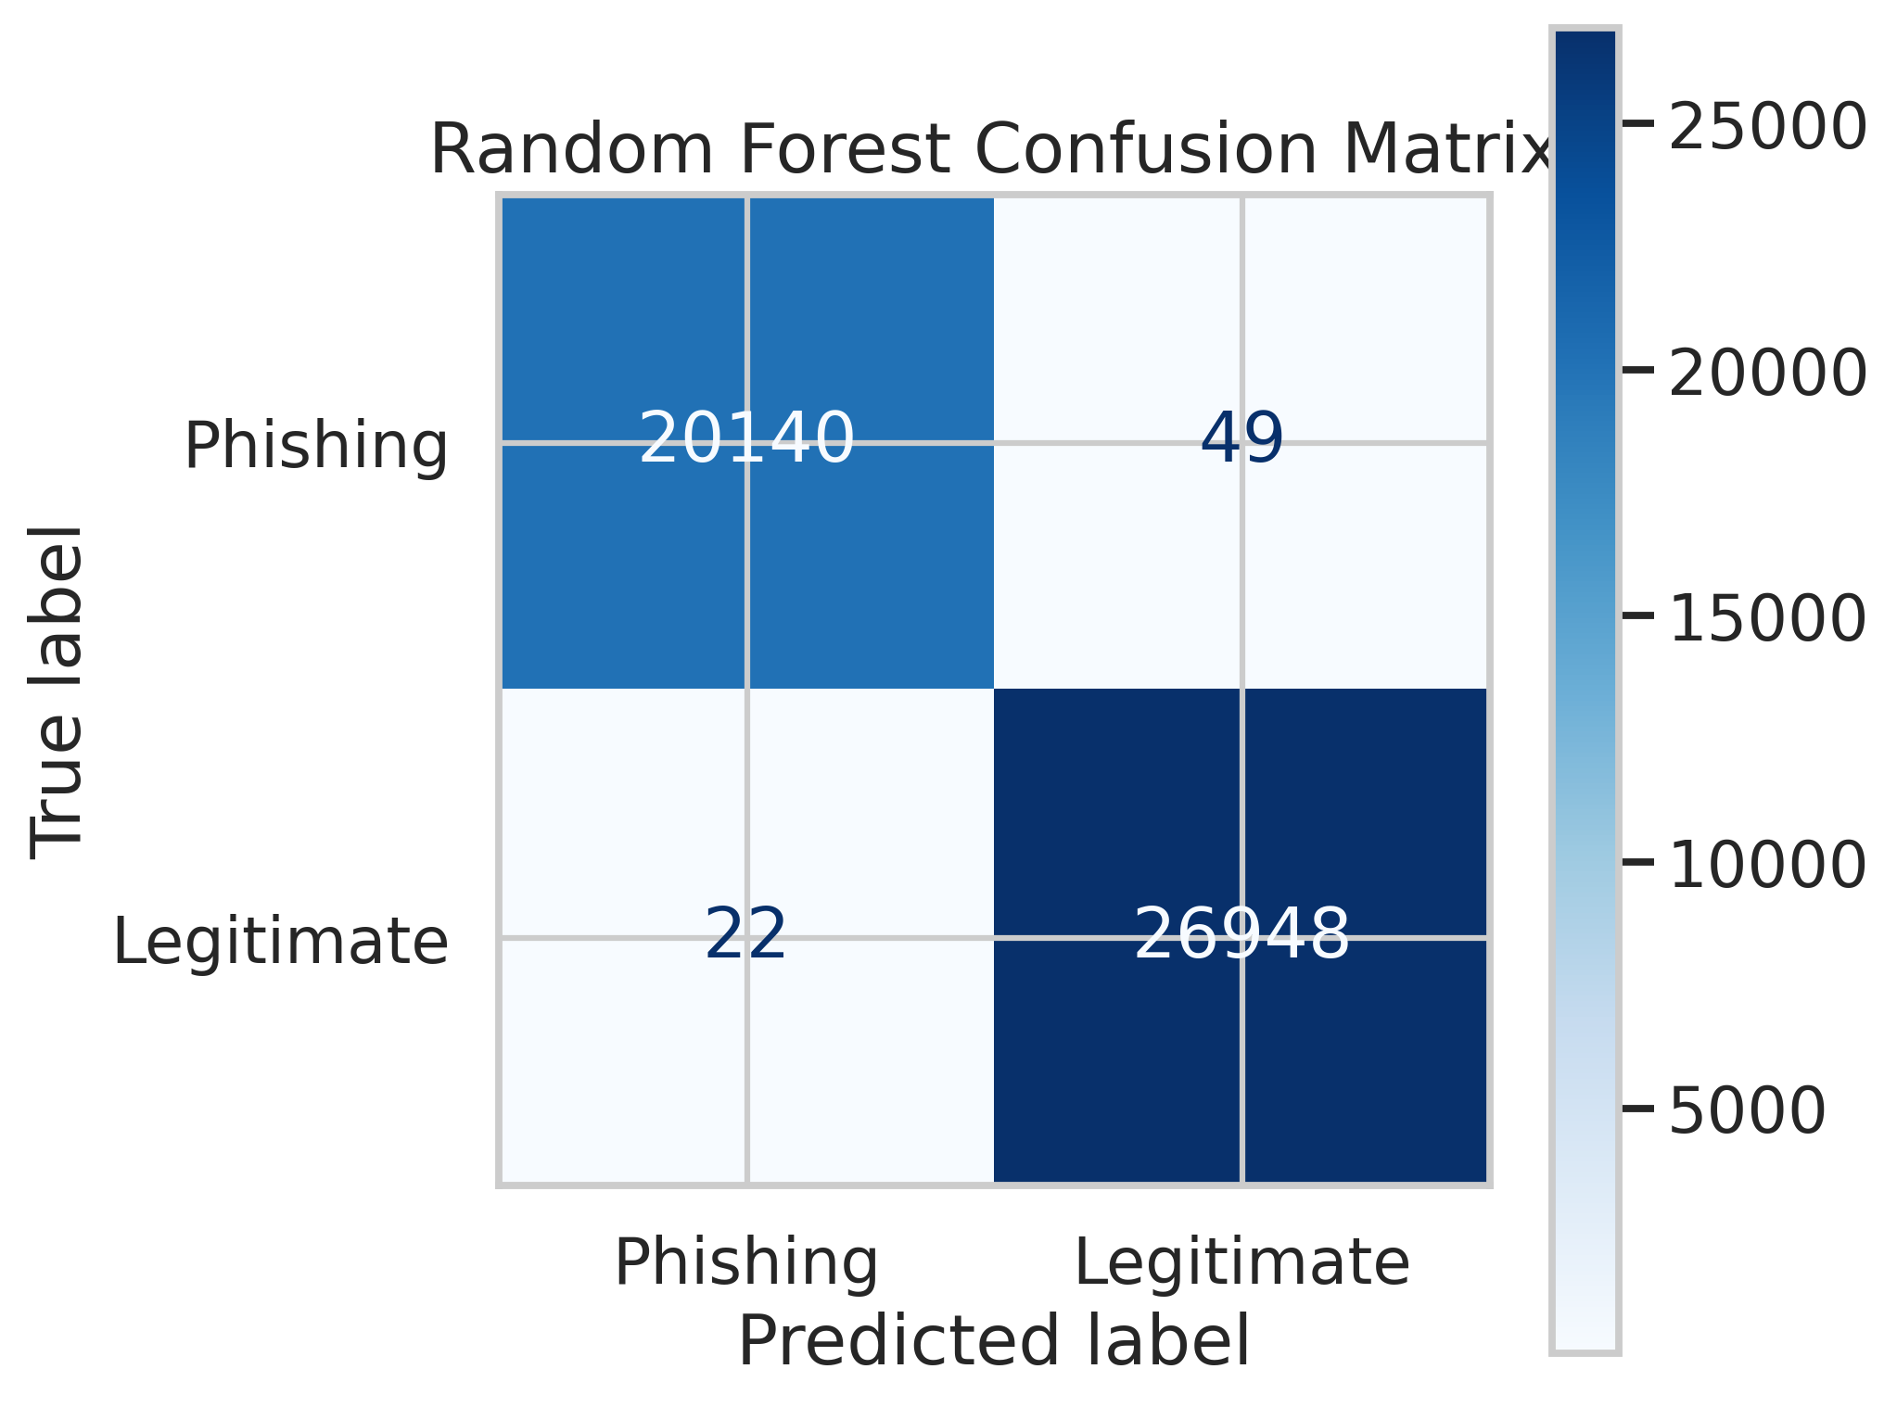
- Confusion matrix for the held-out Random Forest test set.
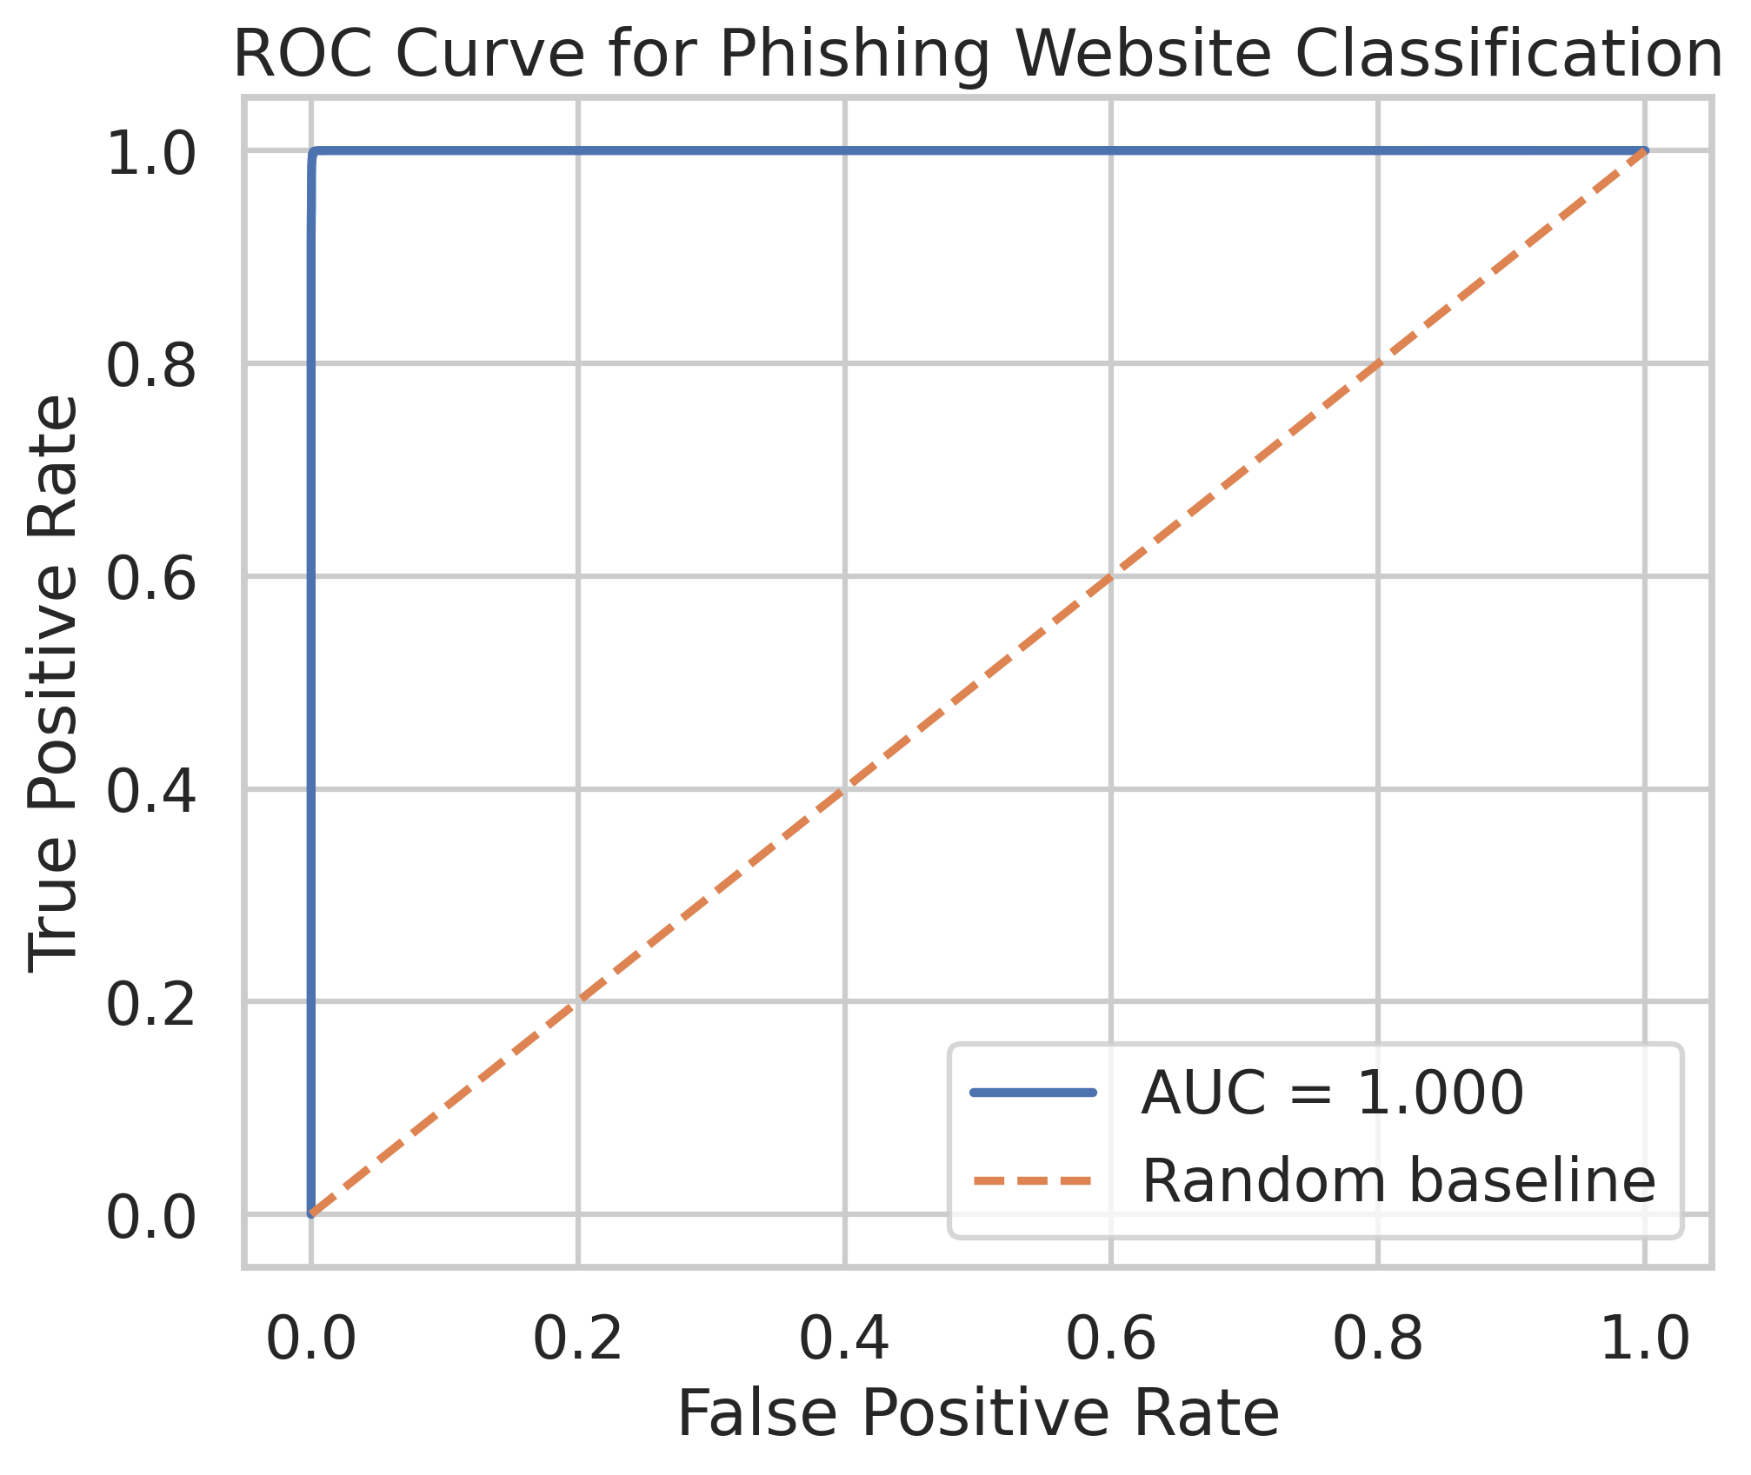
- ROC curve for the held-out test set, with legitimate websites as the positive class.

Expected Results and Applications
The notebook-generated Random Forest baseline produced an accuracy of 99.85%, phishing precision of 99.89%, phishing recall of 99.76%, phishing F1-score of 99.82%, and ROC-AUC of approximately 1.000 on a stratified random test split. These values are preliminary and must not be interpreted as proof of production-level or zero-day detection. The unusually high scores warrant a feature-leakage audit, duplicate and near-duplicate checks, and an independent or time-separated evaluation before the values are presented as final findings. The present experiment evaluates a baseline classifier, not the complete adaptive and explainable framework. Performance comparisons with prior studies remain tentative because datasets, feature sets, label definitions, and evaluation protocols differ [9], [10], [12], [15], [18].
The framework has potential applications in personal cybersecurity tools, browser-integrated protection, educational institutions, financial organizations, and enterprise security-monitoring systems.

Conclusion and Future Scope
This paper proposes an adaptive multi-feature machine learning framework for explainable phishing website detection. The design combines URL, domain, HTTPS, redirection, and webpage-derived signals with classification, risk assessment, and controlled model updating. The baseline experiment and exploratory figures provide an initial evaluation path, but they do not yet validate the complete adaptive framework. Further work should audit feature leakage, test generalization across datasets or collection periods, add per-prediction explanations, and evaluate the effect of controlled retraining before deployment. The literature indicates that generalization, explainability, feature selection, and adversarial robustness should be treated as complementary requirements [9], [11], [14], [17], [20]–[23].
Future work includes continuous retraining on newly reported phishing campaigns, transformer-based URL and HTML encoders, and a browser extension that moves the system from prototype to live protection.

References
- A. Kulkarni and L. L. Brown III, “Phishing websites detection using machine learning,” Int. J. Adv. Comput. Sci. Appl. (IJACSA), vol. 10, no. 7, 2019.
- “Phishing website detection using machine learning,” in Proc. IEEE Conf., 2022.
- “Phishing website detection using hybrid machine learning model,” in Proc. IEEE Conf., 2024.
- “Phishing sites detection using machine learning,” in Proc. IEEE Conf., 2024.
- “Phishing site analyzer: AI-driven real-time detection with MLP and Flask,” in Proc. Springer Conf., 2025.
- “Phishing website detection using deep learning models,” in Proc. IEEE Conf., 2025.
- UCI Machine Learning Repository, “PhiUSIIL phishing URL dataset.” [Online]. Available: https://archive.ics.uci.edu/dataset/967/phiusil-phishing-url-dataset
- UCI Machine Learning Repository, “Phishing websites dataset.” [Online]. Available: https://archive.ics.uci.edu/dataset/327/phishing
- F. Rashid, B. Doyle, S. C. Han, and S. Seneviratne, “Phishing URL detection generalisation using Unsupervised Domain Adaptation,” Computer Networks, vol. 245, art. 110398, 2024, doi: 10.1016/j.comnet.2024.110398.
- N. Reyes-Dorta, P. Caballero-Gil, and C. Rosa-Remedios, “Detection of malicious URLs using machine learning,” Wireless Networks, vol. 30, pp. 7543–7560, 2024, doi: 10.1007/s11276-024-03700-w.
- B. V. Pavani, D. Mahitha, and B. U. Maheswari, “Enhancing Online Safety: Phishing URL Detection Using Machine Learning and Explainable AI,” in Proc. 15th Int. Conf. Computing Communication and Networking Technologies (ICCCNT), 2024, doi: 10.1109/ICCCNT61001.2024.10723976.
- “An integrated model based on deep learning classifiers and pre-trained transformer for phishing URL detection,” Future Generation Computer Systems, vol. 161, pp. 269–285, 2024, doi: 10.1016/j.future.2024.06.031.
- “Phishing URL Detection Using Machine Learning and Deep Learning,” in Proc. IEEE World AI IoT Congress (AIIoT), 2024, doi: 10.1109/AIIOT61789.2024.10579005.
- “A Study on Adversarial Sample Resistance and Defense Mechanism for Multimodal Learning-Based Phishing Website Detection,” IEEE Access, vol. 12, pp. 137805–137824, 2024, doi: 10.1109/ACCESS.2024.3436812.
- F. Trad, E. Semaan-Nasr, and A. Chehab, “MLPhishChain: a machine learning-based blockchain framework for reducing phishing threats,” Frontiers in Blockchain, vol. 7, art. 1484894, 2024, doi: 10.3389/fbloc.2024.1484894.
- O. C. Godfrey, Y. G. Fwa, and A. N. Edmund, “Phishing URL Detection: A Basic Machine Learning Approach,” The International Journal of Science & Technoledge, vol. 12, no. 3, 2024, doi: 10.24940/theijst/2024/v12/i3/ST2403-001.
- “Context-aware embeddings for robust multiclass fraudulent URL detection in online social platforms,” Computers and Electrical Engineering, vol. 119, art. 109494, 2024, doi: 10.1016/j.compeleceng.2024.109494.
- “Automatic phishing website detection and prevention model using transformer deep belief network,” Computers & Security, vol. 147, art. 104071, 2024, doi: 10.1016/j.cose.2024.104071.
- “Mutual information based logistic regression for phishing URL detection,” Cyber Security and Applications, vol. 2, art. 100044, 2024, doi: 10.1016/j.csa.2024.100044.
- “A case study on phishing detection with a machine learning net,” International Journal of Data Science and Analytics, published online June 12, 2024, doi: 10.1007/s41060-024-00579-w.
- “An explainable feature selection framework for web phishing detection with machine learning,” Data Science and Management, vol. 8, no. 2, pp. 127–136, 2025, doi: 10.1016/j.dsm.2024.08.004.
- S. Mousavi and M. Bahaghighat, “Phishing Website Detection: An In-Depth Investigation of Feature Selection and Deep Learning,” Expert Systems, vol. 42, no. 3, art. e13824, 2025, doi: 10.1111/exsy.13824.
- M. C. Calzarossa, P. Giudici, and R. Zieni, “An assessment framework for explainable AI with applications to cybersecurity,” Artificial Intelligence Review, vol. 58, art. 150, 2025, doi: 10.1007/s10462-025-11141-w.
- T. Dalton, H. Gowda, G. Rao, S. Pargi, A. Hadj Khodabakhshi, J. Rombs, S. Jou, and M. Marwah, “PhreshPhish: A Real-World, High-Quality, Large-Scale Phishing Website Dataset and Benchmark,” arXiv:2507.10854, 2025. [Online]. Available: https://arxiv.org/abs/2507.10854.

